**Year 8 Geology EXAM 2013**

Please place your student identification label in this box

**Multiple choice answer grid**

**1** A B C D

**2** A B C D

**3** A B C D

**4** A B C D

**5** A B C D

**6** A B C D

**7** A B C D

**8** A B C D

**9** A B C D

**10** A B C D

**11** A B C D

**12** A B C D

**13** A B C D

**14** A B C D

**15** A B C D

**16** A B C D

**17** A B C D

**18** A B C D

**19** A B C D

**20** A B C D

**21** A B C D

**22** A B C D

**23** A B C D

**24** A B C D

**25** A B C D

**26** A B C D

**27** A B C D

**28** A B C D

**29** A B C D

**30** A B C D

**31** A B C D

**32** A B C D

**33** A B C D

**34** A B C D

**35** A B C D

**36** A B C D

**37** A B C D

**38** A B C D

**39** A B C D

**40** A B C D

|  |  |
| --- | --- |
| C:\Users\s.kanakis\AppData\Local\Microsoft\Windows\Temporary Internet Files\Content.Word\ACC Logo_L_rgb_lrg.jpg | **/67**  **Aranmore Catholic College**  **Semester 2 Examination, 2013**  **Question/Answer Booklet** |

/67

Please place your student identification label in this box

**Year 8 Science**

Student Name

Student’s Teacher

**Time allowed for this paper**

Reading time before commencing work: 10 minutes

Working time for paper: 60 minutes

**Materials required/recommended for this paper**

To be provided by the supervisor This Question/Answer Booklet

Separate Multiple Choice Answer Sheet

To be provided by the candidate Standard items: pens, pencils, eraser, correction fluid, ruler, highlighters.

Special items: non-programmable calculators

**Important note to candidates**

No other items may be taken into the examination room. It is **your** responsibility to ensure that you do not have any unauthorized notes or other items of a non‑personal nature in the examination room. If you have any unauthorized material with you, hand it to the supervisor **before** reading any further.

**Instructions to candidates**

Part A: Circle or cross only one letter on the separate Multiple-Choice Answer Sheet. If you consider that two or more of the alternative answers are correct, choose the one you think is best. If you think you know an answer, mark it even if you are not certain you are correct. Marks will NOT be deducted for incorrect answers.

Part B: Write your answers in this Question/Answer Booklet in the spaces provided.

1. Rock that forms from the cementing of deposited particles is called:

A metamorphic rock.

B igneous rock.

C sedimentary rock.

D volcanic rock.

2. A metamorphic rock is formed by the:

A slow cooling of molten magma to form large crystals.

B deposition and cementing of eroded particles.

C rapid cooling of molten magma to form crystals.

D effects of great heat and pressure on rock.

3. Gabbro is a dark-coloured intrusive igneous rock. A reasonable prediction is that:

A crystals in gabbro are difficult to see.

B all the crystals squashed into lines.

C the crystals are quite large.

D the rock has many holes in it.

4. The two most common processes that change a pile of sediment into a sedimentary rock are:

A compaction and cementation.

B weathering and erosion.

C deposition and sedimentation.

D cooling and crystallisation.

5. The water holding capacity of soils will be greater if:

A there is a lot of clay in the soil.

B there are large pore spaces in the soil.

C there are large crumbs.

D the soil contains a lot of sand.

6. The structure of a soil refers to:

A the size of the particles.

B how well the soil particles join up into crumbs.

C how fast water enters the soil.

D the tendency of soil particles to stick together.

7. Coal is a sedimentary rock that forms when:

A plants fall into lava and become burned to a black charcoal.

B bacteria in soil partially decompose and leave behind a black residue.

C tiny ancient single celled organisms became buried under soil that turned into rock.

D plants are buried and compressed between rock layers.

8. Basalt is formed when lava cools. What type of rock is it?

A Intrusive Igneous Rock

B Extrusive Igneous Rock

C Metamorphic

D Sedimentary

9. Magma and lava

A Are both types of rock

B Are both minerals

C Are both forms of molten rock

D Are exactly the same thing

[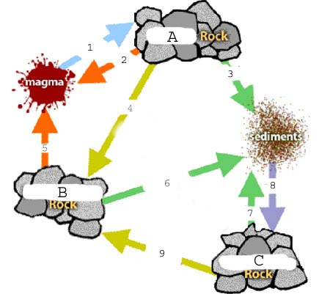](http://www.google.com.au/url?sa=i&rct=j&q=Rock%20Cycle%20worksheet&source=images&cd=&docid=ZENuNbzajXs61M&tbnid=bhk7QoM3MA3nYM:&ved=0CAUQjRw&url=http://www.picstopin.com/860/blank-rock-cycle-diagram/http:||westsidercd*org|Images|Water_cycle*png/&ei=VJqNUvnLLMLnkAWwooGADQ&psig=AFQjCNEZ9MIU_Nj8YJa5qCyPmvtX0PL-zA&ust=1385098155122064)

The following questions refer to the diagram above

10. Which of the following show the rocks labelled correctly?

|  |  |  |  |
| --- | --- | --- | --- |
|  | **Rock A** | **Rock B** | **Rock C** |
| A | Metamorphic | Sedimentary | Igneous |
| B | Igneous | Metamorphic | Sedimentary |
| C | Sedimentary | Igneous | Metamorphic |
| D | None of the above | | |

11. Which of the following describes the processes occurring at arrow number 7?

A Heat & Pressure

B Cooling

C Weathering

D All of the above

12. Which other arrows show the same process?

A 9

B 3 and 6

C 8

D 4 & 9

13. Which of the following describes the processes occurring at arrow number 1?

A Heat & Pressure

B Cooling

C Weathering

D All of the above

14. Water entering cracks in the rock then expanding when the temperature goes below 0oC is an example of

A Erosion

B Physical Weathering

C Chemical Weathering

D Sedimentation

15. Particles being deposited at the bottom of a stream is an example of:

A Erosion

B Physical Weathering

C Weathering

D Sedimentation

16. A piece of rock was caught in ice at the beginning of winter. As spring came and the ice thawed the piece of rock travelled down the hill with the melting ice. This is an example of:

A Erosion

B Physical Weathering

C Chemical Weathering

D Sedimentation

17. Which of the following is **not** a form of physical weathering?

A Acid rain

B Glacier action

C Tree roots

D Ice in the cracks of rocks

18. Which of the following is correct about soil?

A Soil contains organic matter

B Sediment is the basic component of soil

C Soil contains living organisms

D All of the above are correct

Use the table below to answer the following questions:

[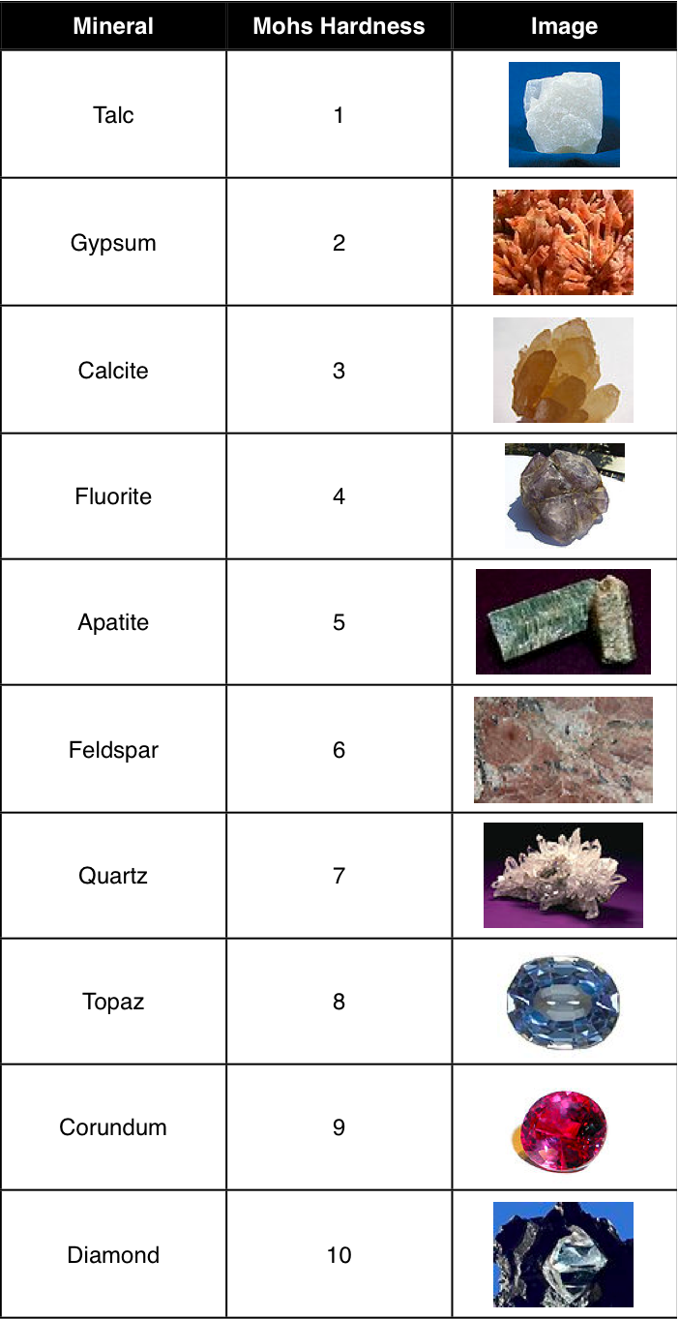](http://www.google.com.au/url?sa=i&rct=j&q=mohs+scale+hardness&source=images&cd=&cad=rja&docid=1xA8nTXSo118AM&tbnid=-O_hESa7eZ5H2M:&ved=0CAUQjRw&url=http://umwgold.com/2013/05/03/basic-geology-stuff-you-may-want-to-know/&ei=8Z2NUvWrMIXDkQW894DYDQ&psig=AFQjCNHxGr6cstJUO7V9ekmiOe1wIpBYHg&ust=1385099017560653)

19. What is the name of the scale shown above?

A The Hardness Scale

B Mohs Hardness Scale

C Barneys Hardness Scale

D None of the above

20. A fingernail has a hardness of 2.5 using the harness scale. If a substance can not be scratched using a fingernail this means:

A It must be Talc or Gypsum

B It mustn’t be a mineral

C It must have a hardness greater than 2.5

D None of the above

21. Glass has a hardness of 5.5 using the harness scale. If a substance can be scratched by glass this means:

A It must be Apatite

B It could be Flourite, Calcite, Gypsum or Talc

C It must have a hardness greater than 5.5

D It could be Feldspar, Quartz, Topaz Corundum or a Diamond

22. What is the name of the test being conducted in the picture below?

[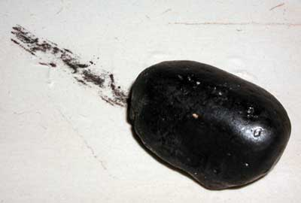](http://www.google.com.au/url?sa=i&rct=j&q=streak+test&source=images&cd=&cad=rja&docid=3S2_1xcLAMx0PM&tbnid=NuaY4aFoUbBf3M:&ved=0CAUQjRw&url=http://meteorite-identification.com/streak.html&ei=TM-SUtnmEsvNlAWZxYDoCg&psig=AFQjCNH18vM-Y3oOuYf9_O-IfdJwUzyACg&ust=1385439275081514)A Flame test

B Hardness test

C Colour test

D Streak test

23. An ore is

A A mineral

B An igneous rock

C A rock containing minerals

D A rock containing crystals

24. Which is the best definition for a resource?

A Substances found in the natural environment

B Fossil fuels such as oil and gas

C Anything that humans use for their own purposes

D Minerals found in rocks

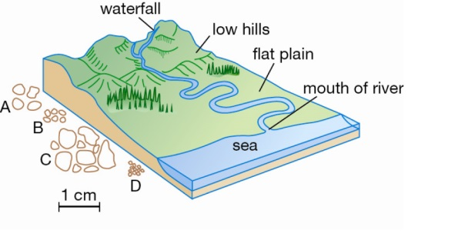

The following questions refer to the diagram above:

25. The largest rocks would be found deposited:

A At the base of the waterfall

B In the low hills area

C Along the flat plain

D At the mouth of the river

26. This is because:

A The water has the most energy there

B There is the largest volume of water there

C It is closest to the source

D All of the above

27. Sedimentary rock made from weathered sediments of other rocks:

A Clastic

B Chemical

C Organic

D Extrusive

28. Sedimentary rock that form when dissolved materials precipitate from solution:

A Clastic

B Chemical

C Organic

D Extrusive

29. Sedimentary rock formed by the accumulation of plant of animal debris which is them cemented together:

A Clastic

B Chemical

C Organic

D Extrusive

30. The best definition for mining is:

A The search for rocks containing the minerals, coal or oil

B The removal of the resource from the ground

C Concentrating the amount of resource found in a particular volume

D Chemical process to remove the wanted element from the ore

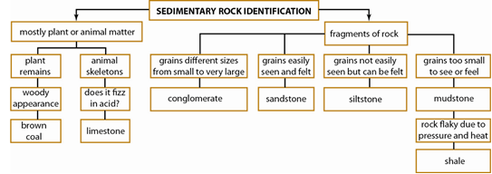

Use the key above to answer the following questions

31. Which of the following is **NOT** true about Brown Coal?

A It is formed from plant remains

B It is a sedimentary rock

C It is flaky

D It has a woody appearance

32. Which of the following is **NOT** true about Shale?

A It is formed from plant remains

B It is a sedimentary rock

C It is flaky

D Its grains are too small to see

33. You could tell the difference between siltstone and conglomerate by:

A Looking at the grains closely

B Feeling for the grains

C Testing if it were made of plant or animal material

D Conducting a flame test

34. The best definition for enrichment is:

A The search for rocks containing the minerals, coal or oil

B The removal of the resource from the ground

C Concentrating the amount of resource found in a particular volume

D Chemical process to remove the wanted element from the ore

35. The best definition for extraction is:

A The search for rocks containing the minerals, coal or oil

B The removal of the resource from the ground

C Concentrating the amount of resource found in a particular volume

D Chemical process to remove the wanted element from the ore

36. The best definition for exploration is:

A The search for rocks containing the minerals, coal or oil

B The removal of the resource from the ground

C Concentrating the amount of resource found in a particular volume

D Chemical process to remove the wanted element from the ore

37. The minerals found in igneous rocks are:

A formed by the crystallisation of magma

B formed when the solutions flowing through them crystallise as the water evaporates

C formed when rocks are put under intense heat and pressure

D None of the above

38. The minerals found in sedimentary rocks may be:

A formed by the crystallisation of magma

B formed when the solutions flowing through them crystallise as the water evaporates

C formed when rocks are put under intense heat and pressure

D None of the above

39. The minerals found in metamorphic rocks are:

A formed by the crystallisation of magma

B formed when the solutions flowing through them crystallise as the water evaporates

C formed when rocks are put under intense heat and pressure

D None of the above

40. Which of the following is INCORRECT about oil and gas

A they are natural resources

B they are minerals

C they are formed from microscopic plants and animals

D they were formed millions of years ago

**Part B - Short Answer:**

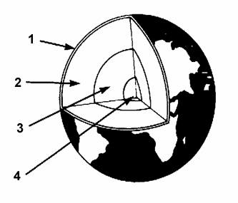1. Label the following diagram of the layers of the earth: **4**

[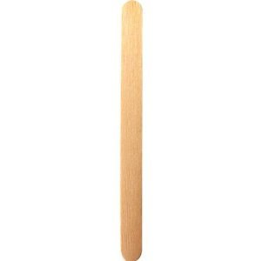](http://www.google.com.au/url?sa=i&rct=j&q=popstick&source=images&cd=&cad=rja&docid=UCQQnz8W2G6mwM&tbnid=E5WZq5e07HXw_M:&ved=0CAUQjRw&url=http://www.amazon.com/Popsicle-Sticks-Box-of-1000/dp/B003UCFPJ6&ei=PtuSUtieBsydlQWquIDQDw&psig=AFQjCNHECAfTUHcjeahKBidNXq4B397Xhg&ust=1385442481073477)

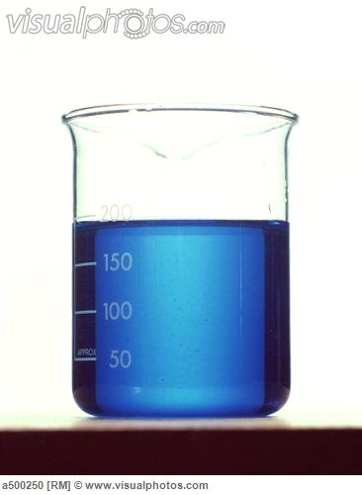2. Mrs Roche and Mr Lafferty found a rock in the Science Lab that had lost its label. Mrs Roche thought the rock was an ore containing copper, Mr Lafferty disagreed and said it was an ore containing Calcium.

They decided to test the rock by grinding some into a powder and dissolving it in water. They then soaked a popstick in the solution. They also soaked another popstick in distilled water.

They used the flame test to determine which mineral was present in the rock.

What is the flame test? **2**

Why did they test a pop stick soaked in distilled (pure) water not just the one soaked in the mineral? **2**

[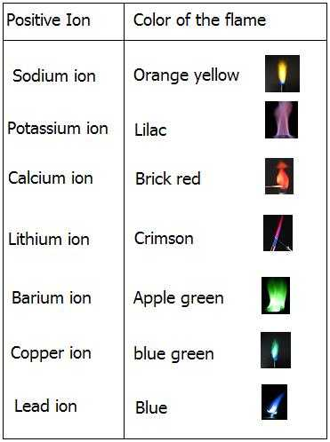](http://www.google.com.au/url?sa=i&rct=j&q=flame+test&source=images&cd=&cad=rja&docid=YaMC13D8AKMSKM&tbnid=puFUusQ6QxV0dM:&ved=0CAUQjRw&url=http://science.csustan.edu/chem1112_4/PDF_Synthesis_of_Table_Salt_Final.pdf&ei=oqqOUqK6BYqQlQW99ICYCA&psig=AFQjCNFBUu2OTY0byEyk5EgTaSWadVzB1w&ust=1385167771154419)

Using the table above, what result would you expect if Mr Lafferty was right? **1**

If the flame was blue what conclusion could you make? **1**

3. Two Geologists were testing the rocks formed after the eruption of two volcanoes, Mount Aran and Mount More. They wanted to see after which eruption the rocks cooled and solidified faster.

They collected four 100g samples from each site then brought them back to the lab to measure the size of the crystals in each. They measured the size of 4 crystals in each sample and worked out the average.

What may have been the hypothesis for this experiment? **2**

What was the independent variable? **1**

What was the dependent variable? **1**

List 2 variables that were controlled **2**

Give one more variable that should have been controlled. **1**

The results are shown below.

|  |  |  |
| --- | --- | --- |
| **Average crystal size in site** | **Mount Aran crystal size in mm** | **Mount More Crystal size in mm** |
| 1 | 1 | 0.5 |
| 2 | 1.5 | 1 |
| 3 | 3 | 0.5 |
| 4 | 5 | 1.5 |
|  | AVERAGE | AVERAGE |

Fill in the average crystal size above. **2**

Graph the results below: **5**

*There is a spare grid on the next page if you make a mistake on this one*



After which eruption did the rocks form faster? **1**

How can you tell? **2**

**Spare Graphing Grid**



**END OF EXAM**

**The following activities are not assessed, they are just for fun**

[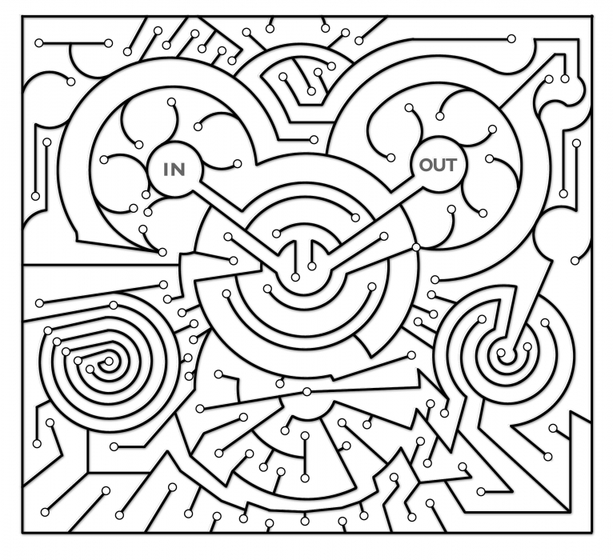](http://www.google.com.au/url?sa=i&rct=j&q=maze&source=images&cd=&cad=rja&docid=-RerTsqn6sdzOM&tbnid=hhRQQ7iyhKHrRM:&ved=0CAUQjRw&url=http://coolrain44.wordpress.com/2009/11/21/maze-craze/&ei=zoB8Uru0KYLHkwW8xYGQCA&psig=AFQjCNHsPhFfeqCrPh2S-Aw3c9lFVctb8w&ust=1383977541394794)[](http://www.google.com.au/url?sa=i&rct=j&q=science+maze&source=images&cd=&cad=rja&docid=qp_6f0LyDeAe8M&tbnid=rAwnOFEaCUPSbM:&ved=0CAUQjRw&url=http://nagonthelake.blogspot.com/2010_11_01_archive.html&ei=2oF8Usr8MofZkQXtsYHgAw&psig=AFQjCNE2HFr6EQYj5V1nMwjUhfzm_PjPug&ust=1383977814401725)

[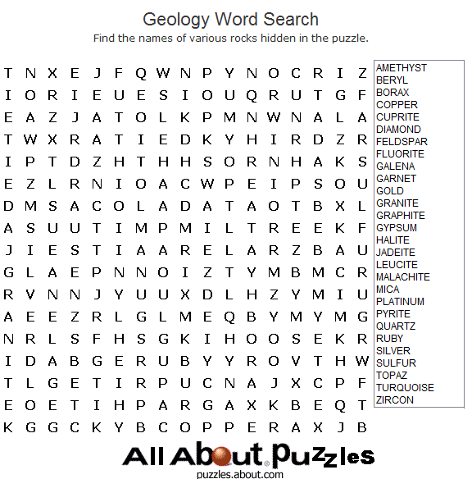](http://www.google.com.au/url?sa=i&rct=j&q=word+search+geology&source=images&cd=&cad=rja&docid=c1BaSzoNm6aJsM&tbnid=4ky8YHtfXZJ54M:&ved=0CAUQjRw&url=http://puzzles.about.com/od/wordsearches/ig/Printable-WS/Geology.htm&ei=tdOSUtyyHIPDkwXl2YGgBg&psig=AFQjCNGeSnub76T8pYapgquP1WnWd7nezA&ust=1385440501423501)

[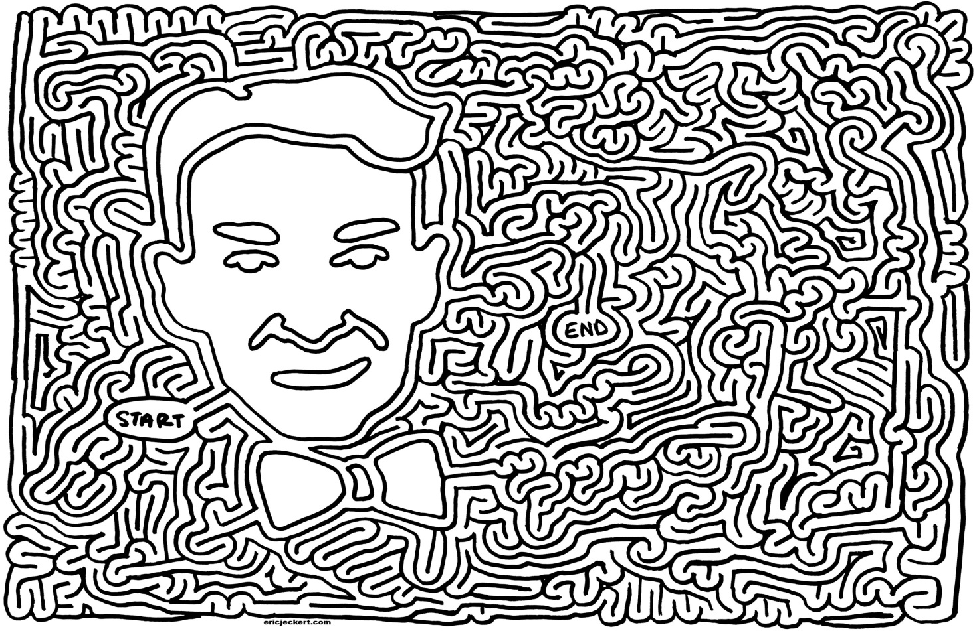](http://www.google.com.au/url?sa=i&rct=j&q=maze+science&source=images&cd=&cad=rja&docid=7w-8P1fpQ0ZGnM&tbnid=eh0Ca-idXYHMaM:&ved=0CAUQjRw&url=http://ericjeckert.com/&ei=QNOSUprENoewkgXu5IBI&psig=AFQjCNGNmDh2Jwbib59v-WKYSvgEyWxrqw&ust=1385440373769590)

**Year 8 Geology EXAM 2013**

SOLUTIONS

**Multiple choice answer grid**

**1** A B C D

**2** A B C D

**3** A B C D

**4** A B C D

**5** A B C D

**6** A B C D

**7** A B C D

**8** A B C D

**9** A B C D

**10** A B C D

**11** A B C D

**12** A B C D

**13** A B C D

**14** A B C D

**15** A B C D

**16** A B C D

**17** A B C D

**18** A B C D

**19** A B C D

**20** A B C D

**21** A B C D

**22** A B C D

**23** A B C D

**24** A B C D

**25** A B C D

**26** A B C D

**27** A B C D

**28** A B C D

**29** A B C D

**30** A B C D

**31** A B C D

**32** A B C D

**33** A B C D

**34** A B C D

**35** A B C D

**36** A B C D

**37** A B C D

**38** A B C D

**39** A B C D

**40** A B C D

**Part B - Short Answer:**

1. Label the following diagram of the layers of the earth: **4**

Crust

Mantle

Outer Core

Inner Core

2. Mrs Roche and Mr Lafferty found a rock in the Science Lab that had lost its label. Mrs Roche thought the rock was an ore containing copper, Mr Lafferty disagreed and said it was an ore containing Calcium.

They decided to test the rock by grinding some into a powder and dissolving it in water. They then soaked a popstick in the solution. They also soaked another popstick in distilled water.

They used the flame test to determine which mineral was present in the rock.

What is the flame test? **2**

Colour of flame 1

Indicates type of mineral 1

Why did they test a pop stick soaked in distilled (pure) water not just the one soaked in the mineral? **2**

Control 1

So the effect of the popstick and distilled water are known 1

[](http://www.google.com.au/url?sa=i&rct=j&q=flame+test&source=images&cd=&cad=rja&docid=YaMC13D8AKMSKM&tbnid=puFUusQ6QxV0dM:&ved=0CAUQjRw&url=http://science.csustan.edu/chem1112_4/PDF_Synthesis_of_Table_Salt_Final.pdf&ei=oqqOUqK6BYqQlQW99ICYCA&psig=AFQjCNFBUu2OTY0byEyk5EgTaSWadVzB1w&ust=1385167771154419)

Using the table above, what result would you expect if Mr Lafferty was right? **1**

Red

If the flame was blue what conclusion could you make? **1**

That the ore contained Lead

3. Two Geologists were testing the rocks formed after the explosion of two volcanoes, Mount Aran and Mount More. They wanted to see after which explosion the rocks cooled and solidified faster.

They collected four 100g samples from each site then brought them back to the lab to measure the size of the crystals in each. They measured the size of 4 crystals in each sample and worked out the average.

What may have been the hypothesis for this experiment? **2**

Worded correctly 1

Mention Ind & Dep variables 1

What was the independent variable? **1**

Which eruption or which volcano

What was the dependent variable? **1**

Crystal size

List 2 variables that were controlled **2**

Any two of:

Size of sample, number of samples, number of crystals measured

Give one more variable that should have been controlled. **1**

Any suitable answer

The results are shown below.

|  |  |  |
| --- | --- | --- |
| **Average crystal size in site** | **Mount Aran crystal size in mm** | **Mount More Crystal size in mm** |
| 1 | 1 | 0.5 |
| 2 | 1.5 | 1 |
| 3 | 3 | 0.5 |
| 4 | 5 | 1.5 |
|  | AVERAGE 2.6 | AVERAGE 0.88 |

Fill in the average crystal size above. **2**

Graph the results below: **5**

Minus one mark for any of the following missing:

Neat.

Use ruler

Correct

Axis drawn

Pencil

Ind var on horizontal

Scale correct

Title

Labels

Units

After which eruption did the rocks form faster? **1**

Mount More

How can you tell? **2**

The crystals are smaller 1

Faster cooling leads to smaller crystals 1